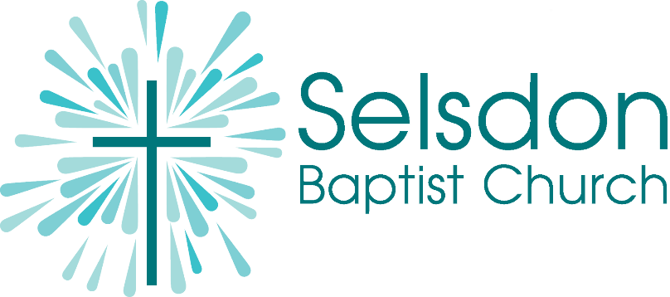
Children and Families Worker, Selsdon Baptist Church
Full Time, permanent role (40 hours per week), Salary £24-26,000 p.a. plus accommodation.
SBC is a growing, vibrant and multicultural congregation on the outskirts of South Croydon.
We’re seeking to recruit a Children and Families Worker, fulfilling our vision to be a God-centred, serving, kingdom-shaped, generous, courageous and contemplative church, and to reach out to children and families in our community.
Increasingly multicultural, and with excellent transport links to London but also a short drive from the countryside of Surrey and Kent, Selsdon is a great place to live and minister. You’ll have the opportunity to be part of a team ministry, serving a diverse church made up of many different nationalities.
There is a genuine occupational requirement that the post-holder is a practising Christian. Appointment will be subject to three satisfactory references and an enhanced DBS check. Part-time or job-sharing arrangements will be considered, but accommodation will be provided only to those willing to take up the appointment on a full-time basis.
For a full job description and application form, please contact office@selsdonbaptist.org.uk.
Closing date for applications: 10th February 2023

